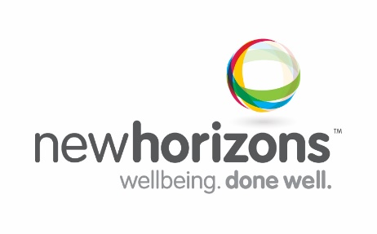
Position Description :
Role/Department: Mental Health Clinician (headspace) Role reports to: Team Leader
Classification/Level: 3 Location: Ashfield
Our Vision and Organisation’s Purpose
Working toward our vision of happy, inclusive communities creating opportunities, our diverse team shares a common purpose to enhance wellbeing
Position Summary and Purpose
Provide person-centered clinical services as part of a multidisciplinary team to young people aged 12 – 25 years who have a diagnosable moderate/severe mental illness/ have attempted/are at risk of suicide/self-harm where access to other services is not appropriate. Services provided are in conjunction with the Psychological Support Services Program (PSS) whereby young people in hard to reach groups, can be referred by a GP for focused psychological intervention/ treatment. Address the mental health and/or co-morbidity issues of underserviced young people such as Aboriginal and Torres Strait Islanders, Culturally and Linguistically Diverse and LGBTIQ+ those eligible for the PSS Services.
Reporting lines and stakeholder relationships
Internal - Reports to the Team Leader. Works with the headspace multidisciplinary team. Required to work positively with all New Horizons employees.
External - Interacts regularly with General Practitioners, Psychiatrists and Paediatricians, relevant stakeholders from the Central & Eastern Sydney Primary Health Network, other headspace centres and service providers, Government agencies, consultants, health professionals, family members/carers and community members.
Key Result Areas
Clinical Service Delivery
- Provide short term focused psychological intervention/treatments
- In consultation with the Team Leader, develop the PSS clinical services to create a system and quality environment that promotes excellence in youth health & support services
- Deliver efficient and consistent evidence based and person-centred services to achieve satisfactory customer outcomes
- Ensure clinical services adhere to relevant guidelines and procedures (both internal and external), and comply with the Mental Health Act, Health Practitioner National Law Act and other relevant legislation
- Develop and maintain up to date information for partner services including referral processes, criteria and waiting times
- Contribute to decisions which affect program activities
- Actively participate in service development, team meetings, quality assurance activities and WH&S initiatives
Relationship Management
- Develop and maintain effective working relationships with key stakeholder groups including customers, community agencies, funding providers, local government and advocacy groups
Administration/Reporting
- Document clear and concise records and maintain security/integrity of data
- Ensure collection and documentation of appropriate customer data to meet the reporting requirements of the Department of Health and New Horizons
- Prepare reports and computer generated statistical information to ensure compliance with funding bodies as required
WH&S
- Demonstrate and promote safe and healthy work practices at all times.
- Recognise workplace hazards in accordance with WHS policies and WorkCover guidelines and deal with them accordingly to mitigate risk.
Key Competencies
- High level of interpersonal, communication skills to effectively engage with stakeholders
- Well-developed planning and organisational skills with ability to prioritise work
- Demonstrated ability to work autonomously and within a multidisciplinary team
- A sound understanding of compliance and protocols in relation to clinical accountability, WHS, privacy legislation and confidentiality
- Current Drivers Licence, Australia Federal Police Check, Working with Children Check
Skills/Knowledge/Experience
- Relevant tertiary qualifications as a Psychologist, Mental Health Nurse, Social Worker or Occupational Therapist, registered with Medicare as a Mental Health Provider. A Social Worker must be a member of the Australian Association of Social Workers (AASW), and meet the standards for ‘Mental Health Social Workers 1999.’
- Registered with AHPRA or relevant professional body
- Minimum 3 years’ experience providing evidence-based treatment to at-risk young people with a range of psychosocial and co-morbidity issues.
- Intermediate Microsoft Office skills

